Jo's Mini-exercises
Core understanding
Exercise 1: What changes when a model becomes Bayesian?
- In your own words, explain what people usually mean when they say they “turn a frequentist model into a Bayesian model.”
They are starting with a simpler linear model, which may be generalised and/or heirarchical, and using the same formula to run a model through a Bayesian engine. The Bayesian model requires additional information in the form of a prior distribution for each value in the formula, and for each output, instead of returning a single value it runs many iterations of the modelling procedure, returning a distribution of possible outputs. These distributions can be compared with a null hypothesis, which may be point zero (like a frequentist model) but may also be a different point or a whole interval, called a ROPE. This comparison can be done with the Savage-Dickey density ratio, which determines how much the data favors the likelihood of the postierior distribution being outside the null hypothesis, compared to the prior (Well, Savage-Dickey is not “how much the data favors the likelihood of the posterior being outside the null”, but rather it is a way of computing a Bayes factor by comparing prior and posterior density at a point null (or related interval-based logic in some workflows). This calculation returns a Bayes Factor, which can be interpreted in terms of levels of uncertainty, making the result more informative than a frequentist model, which only returns a comparison to point null.
- Identify the roles of the likelihood, the prior, and the posterior.
I'm not sure what 'likelihood' means here. Oh? How so? with Bayesian statistics, the likelihood tells us how compatible the observed data are with different parameter values under the model
The prior for a given parameter is a distribution of plausible values we think the parameter could have, given the information we have before seeing the data.
The posterior for the same parameter is a distribution of plausible values the model predicts for it, having seen both the priors and the data. (Or, more simply/clearly: Posteriors are priors updated by the likelihood after seeing the data)
Exercise 2: Match the prior to the parameter class
- For each parameter class below, state what kind of quantity it represents and name one prior family that is commonly used for it in brms:
  - class = "Intercept": the overall intercept of the response variable; normal distribution (ok)
  - class = "b": a predictor variable's effect on the response variable; student_t or normal distribution (ok)
  - class = "sd": the variance associated with a random effect; Cauchy (Well, it is not the variance, but the standard deviation of the random effects / group-level effects
  - class = "sigma": the overall residual error, or leftover variation (yes, residual SD in a Gaussian model); student_t
- Then explain why the same prior would not automatically make equal sense across all four classes.
As for normal vs. student_t, I'm not sure when each is appropriate. Student_t captures more density in its tails, so is particularly suited to setting more diffuse priors. Cauchy priors I do not understand. The same prior does not automatically make sense across all these classes because the parameters live on different scales and mean different things. An intercept prior should usually be chosen on the outcome scale. A slope prior should reflect plausible effect sizes per one-unit change in the predictor. An SD prior must respect positivity and should reflect realistic variability rather than average levels. (A mistake we’ve seen students make is to copy one Normal(0, 1) prior everywhere. That usually makes no sense. Intercepts, slopes, and SD parameters are not interchangeable.) !!!This is one of the most useful habits for later analysis (for the exam) before choosing a prior, ask “What parameter class is this?”
Exercise 3: Priors
- What is a Cauchy prior?
A Cauchy prior is a heavy-tailed probability distribution often written as Cauchy(location, scale). It is centered at its location parameter, and its scale parameter controls how wide it is. Compared with a Normal prior, it places relatively more probability in the tails, which means it is more tolerant of occasional large values.
- How is it related to the Student-t family?
a Cauchy distribution is a Student-t distribution with 1 degree of freedom. In other words, it is an especially heavy-tailed special case of the t family
  - (I think I should maybe clear df up for the group again this year. I said last year that df is the number of independent values in a dataset that are "free to vary" after certain mathematical restrictions (like calculating a mean) have been applied. BUT it means different things in different contexts. in a t-test, degrees of freedom relate to sample size, in regression, they can relate to how many values are free to vary, and in the Student-t distribution, degrees of freedom are a shape parameter. So df=1 here tells us that the Cauchy is the most extreme heavy-tailed (shape) member of the Student-t family …
- Why do people describe it as “heavy-tailed”?
because extreme values retain more prior mass than they would under a Normal distribution. This can be useful when you want the prior to pull estimates gently toward zero near the center, while still allowing large effects if the data demand them.
- Give one situation in which a Cauchy prior may be attractive and one situation in which it may be a poor default choice.
A Cauchy prior may be attractive when a parameter could plausibly be near zero but you do not want to rule out rare large effects too aggressively. It may be a poor default when the outcome scale is such that the heavy tails imply absurd parameter values, or when the heavy tails create computational instability.
Example. If a slope is measured in milliseconds, Cauchy(0, 100) says that very large effects remain quite plausible a priori. That may be too permissive in many problems.
Exercise 4: Half-Cauchy and standard deviations
- Explain why a prior such as cauchy(0, 3) on a standard deviation parameter behaves like a halfCauchy in practice.
…because the parameter itself is constrained to be nonnegative. Standard deviations cannot meaningfully go below zero, so the model effectively uses only the positive half of the Cauchy distribution (i.e. half of it).
- Why are priors on class = "sd" especially important in multilevel models?
Well, I thought those were only used for random effects. … because they regulate how much variation is attributed to groups such as participants or items. If these priors are too narrow, the model may underestimate group-level variability. That in turn can make fixed effects look more certain than they should
- What can happen if the prior on a random-effect SD is too narrow?
It could fail to capture the actual value of the random effect. Would this make the random effect term useless? Yes, it can suppress realistic variation between groups and produce anti-conservative conclusions (I heard in the group that Timo used anti-conservative, but most did not understand what he meant. In plain language, this means that the model may become too confident (not conservative) about the fixed effects because it is not allowing enough variation where it actually belongs

Exercise 5: SESOI
- In your own words, define SESOI.
SESOI stands for smallest effect size of interest, and is the amount of change to the response variable the researcher decides a predictor must affect for it to be a 'meaningful' effect. (Nice)
- Explain the difference between statistical significance and practical importance.
Statistical significance is typically calculated in comparison to zero, i.e. if it's sufficiently unlikely that an effect is zero it is considered statistically significant. Practical importance depends on whether the effect is of a size that actually 'matters' in the world. (Nice)
- Explain the difference between a point null of exactly 0 and an interval null around 0.
An interval null around zero describes an area where an effect in either direction would be small enough no be considered equivalent to zero. (Ah, -ish. I mean yes, but you sort of mixed the two into one sentence and I am not sure how you meant to split them 😊. A point null of exactly 0 asks whether the parameter is precisely zero. An interval null around 0 asks whether the parameter is small enough to count as practically negligible.)
- A posterior for a treatment effect is centered at 0.03, and your SESOI is [-0.10, 0.10]. What is the first practical question you should ask?
What is the spread of the posterior? Is any of it outside the ROPE? If so, what proportion compared to the prior? (This last one already moves toward Bayes factor / prior-posterior logic, so it is not the first practical question to ask. But the rest yes, also considering out context SESOI [-0.10, 0.10]. So more clearly something like: “Is most of the posterior inside the interval of practical equivalence?” (i.e. Is most of the posterior inside the SESOI interval, or is substantial posterior mass outside it?))
- A researcher says, “Any effect above zero matters.” What is wrong with that claim?
If the predicted effect is too small to be measurable with the research equipment used, it's meaningless; if it's too small to have practical implications in the world, it's close to meaningless. Well, yes. But, more technically put: The claim “Any effect above zero matters” is wrong because it ignores scale, context, measurement error, and decision consequences. A tiny effect can be real but trivial.
- Why is SESOI always tied to a scale, a context, and a decision problem?
I don't know this formulation, but broadly all of these things decide what an effect may mean in the world; some contexts/decisions are predicated on stronger effects than others. Right. “meaningfulness” is not absolute. It depends on depends on the measurement scale, substantive consequences, and the decision you are trying to make. A 5 ms change may be trivial in one reaction-time paradigm and potentially important in another
Interpretation and diagnosis
Exercise 6: Scale matters
- Suppose you are modeling reaction times in milliseconds. Compare the practical meaning of the following two priors on class = "sd":
  - cauchy(0, 3)
The prior is quite precise, predicting an effect with very little variation. (Careful. The prior is on class = "sd", so it is not directly “predicting an effect.” It is placing prior mass on the sd parameter.)
  - cauchy(0, 100)
The prior is quite broad, predicting an effect which could vary a lot.
- Discuss what each prior says before seeing the data, and why one might be too narrow or too diffuse depending on the scale of the outcome.
The narrow prior may make the outcome seem very powerful if an outcome is measured with a mean of, say, 10ms, as a large mass of data would be away from the prior (or, better put, (instead of “large mass of data away from the prior”: the prior may place too much probability on unrealistically small SD values relative to the scale of the data.)
The diffuse prior may make the outcome seem not very powerful/meaningful even if it's mean is something like 50ms, because that's fully within the prior. (again, remember that the prior is on SD, not the mean. So to tie it all up:
cauchy(0, 3) puts much more prior mass near small SD values, so for reaction times in milliseconds it implies that participant/item variability is expected to be fairly small. cauchy(0, 100) leaves much larger SD values plausible and is much more diffuse. Depending on the RT scale, the first may be unrealistically tight and the second may be too permissive.)
Exercise 7: Weakly or informative priors
- What is a weakly informative prior?
A weakly informative prior diffusely covers an area of values that are conceivable based on the information available. In the case of effects, it's generally centred on zero. (Nice. These priors rule out nonsense while still allowing a broad range of plausible values)
- Why is “as flat as possible” often not the best strategy?
Flat priors reproduce the uninformed prediction in frequentist models, overly favoring values that are absolutely inconceivable. This makes real data values seem more meaningful in comparison. (Yes, but if we say this in stats lingo (and maybe avoid extreme adjectives 😊) we can say that they are not the best strategy because extremely diffuse priors can still be, as you say, informative in bad ways, they can allow absurd values (“absolutely inconceivable”), and can make computation harder. Bayesian practice is usually better served by priors that are broad but still scale-aware.)
- Give one example of how a weakly informative prior can help with estimation, interpretation, or computation.
A weakly informative prior can be used to compute a Bayes factor, as a baseline of conceivable values to compare posteriors to. (i.e. it helps computation by preventing the sampler from wandering into absurd parts of parameter space)
Exercise 8: Matching priors to parameters
- Which parameter classes in a multilevel model usually need different priors: intercepts, slopes, residual SDs, random-effect SDs, or correlations? Explain briefly why they cannot all share the same prior.
The intercept, unlike the rest of them (ok, but you should say should say more clearly that these are different kinds of quantities on different scales and with different support), is typically not centred around zero since it's not a measurement of change or variation. As for the rest, I'm not sure. (Ah, ok. Different parameter classes represent different kinds of quantities on different scales. Intercepts are on the outcome scale. Slopes are on an effect-per-unit scale. SDs are positive-only variability parameters. Correlations are bounded between -1 and 1)
- Why is a prior for a standard deviation usually chosen from a positive-only family or interpreted as truncated/half-distributed?
Standard deviations cannot be negative, as they are a measure of absolute spread. Is this what cauchy does? (Well, yes, half-Cauchy (see above). That is, for a standard deviation parameter, a symmetric prior like cauchy(0, 3) behaves like a half-Cauchy in practice, because the parameter itself is constrained to be nonnegative)
- Why should an intercept prior usually be chosen on the outcome scale rather than copied from a prior used for standardized slopes?
See above; it's a value the data is centred around, which is typically not zero. Yeah, an intercept prior should be chosen on the outcome scale because the intercept represents an expected outcome level, not an effect size.
Exercise 9: Reading results against a SESOI
- Suppose an effect estimate is 0.18 with a 95% credible interval of [0.02, 0.31], and the SESOI is [- 0.10, 0.10]. Write 3-4 sentences interpreting this result from a practical-importance perspective.
While this effect is very likely positive, a little less than 1/3 of effect's posterior is inside the ROPE, so there's a reasonable likelihood that it is not practically meaningful based on the rationale of the SESOI choice. It is more likely than not that it is practically meaningful, but not proven. (Yes. Agreed. The estimate is above the SESOI upper bound, but the interval still includes values inside the SESOI, so there is evidence of a positive effect, but practical importance is not fully certain.)
- Now suppose an effect estimate is 0.05 with a 95% credible interval of [-0.02, 0.12], with the same SESOI. What is uncertain here? Be precise.
It is uncertain whether there is an effect at all, as the 95% CI overlaps with zero, and whether the effect is practically meaningful. There is a plausible, but relatively unlikely case (a little under 1/5 of the posterior (well, that is a little specific 😊 ) that there is a positive, practically meaningful effect. (Indeed, the interval overlaps zero and also overlaps both the SESOI and values just outside it. So we are uncertain about both direction and practical importance. Nice, nice, nice)
- Now suppose an effect estimate is 0.01 with a 95% credible interval of [-0.03, 0.04], again with the same SESOI. What would be the most defensible conclusion?
The most defensible conclusion is that there is no practically important effect. (😊 If the effect estimate is 0.01 with a 95% credible interval of [-0.03, 0.04], the most defensible conclusion is that the result is compatible with practical equivalence, because the entire interval lies comfortably inside the SESOI. This is a case where the effect may be effectively too small to matter. !!!For the exam, remember: A good answer is 2-4 sentences that mention the posterior relative to the SESOI, not just relative to zero.)

Applied work in R
Exercise 10: Writing priors in brms
- Write a brms prior specification for a Gaussian mixed model with these choices:
  - a normal prior for the intercept centered on 750 with scale 200
  - a normal prior for fixed effects centered on 0 with scale 50
  - a Student-t prior for random-effect standard deviations with df = 3, location = 0, scale = 50
  - a Student-t prior for sigma with df = 3, location = 0, scale = 50
  - Write the R code using prior(...) or set_prior(...).
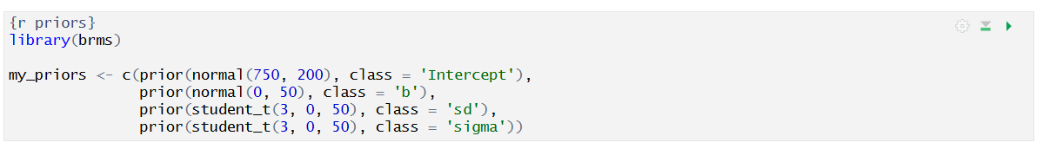
Lovely,lovely.
Exercise 11: Inspecting defaults by overriding them
- What function would you use in brms to inspect priors before fitting a model?
get_prior(model formula, data) (Nice)
- Why is this a good habit?
In case you forgot about a prior that needs to be set? In case the defaults are unexpected and this tells you something? (see below, commented in the code)
- Write a short code example using a formula of your choice. (see below, commented in the code)
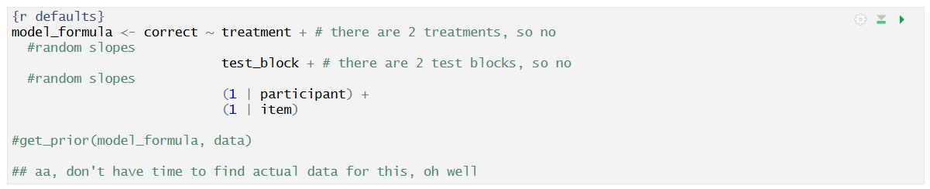
My version:
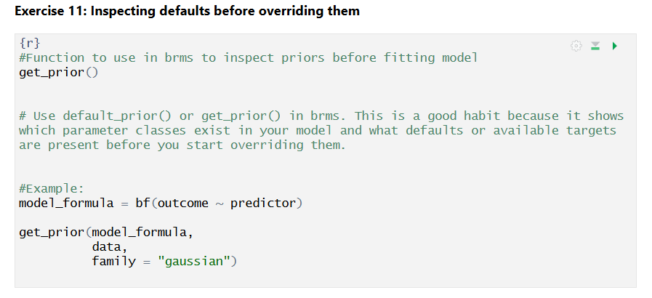
Exercise 12: Sensitivity analysis
- Imagine you fit the same model twice. In Model A you use a narrow prior on class = "sd"; in Model B you use a much wider prior. The posterior intervals for the main effects are noticeably wider in Model B.
- Give two possible interpretations of this result.
  - Model B captures more of the actual variation among participants and items, and reflects that this means the main effects cannot be predicted so consistently. (Nice)
  - Model B predicts more variation among participants and items than there actually is, artificially making the prediction less precise. (Nice)
- Then explain what you would report in a write-up to show that you took prior sensitivity seriously.
The spread of the predicted effect distribution is noticeably affected by the researcher's choices of priors. Outcomes should be interpreted with reference to the priors used in the input. (OK, but as we said before, a write up is 2-4 sentences that tell you something directly relevant. In this case a good write-up would report 1) that sensitivity analysis was conducted, 2) describe the alternative prior choices, 3) summarize how much the posterior changed, and 4) explain whether the substantive conclusion remained the same or became less certain.)
BONUS
1. A student writes: “We used a very wide prior because wide priors are always more objective.” Critique this statement.
Overly wide priors favor more extreme values and make it more difficult for the model to converge on realistic values, as it must rely mostly only on the data. (You are not wrong, but make sure to more precisely critique the key statement (in this case “wide priors are more objective”), should you be asked to. For example: Wide priors are not automatically more objective. They may encode implausible values, create computational problems, or simply avoid the responsibility of scale-aware justification. A prior needs to be defensible, and not just “large”.)
- Another student writes: “Our estimate was statistically different from zero, so it must be practically meaningful.” Critique this statement
Covered this earlier.
- A third student writes: “We did not have time to read the literature, so we chose a SESOI randomly.” Rewrite this into a more defensible sentence.
We chose a SESOI with limited information due to resource constraints. The SESOI should thus be considered a guideline, rather than a strict decision point. (You want to be honest, of course, but “caution, may not be right” is a little too little. Try something like: “Given limited time, we adopted a provisional SESOI based on the outcome scale, likely measurement precision, and what would count as a minimally meaningful effect in this context, and we checked whether the interpretation changed under nearby alternative thresholds.” Again, it is not just about it being excusable, but defensible.)

